**Surface Book Project**

**NIIT**

**Developed by**

**Leader： Lisa**

**Member： Arthur Rose Emily**

**Batch Code : 14j89MTCN-2004**

**Start Date : 25th December , 2015**

**End Date : 07th January, 2016**

**Name of the Coordinator : Shaan**

**Name of the Developer : Lisa Arthur Rose Emily**

**Date of Submission : 08th January, 2016**

**NIIT**

**CERTIFICATE**

This is to certify that this report titled **Surface Book** embodies the original work done by in partial fulfillment of the course requirement at NIIT.

Coordinator:

**Shaan**

**ACKNOWLEDGEMENT**

***We have benefited a lot from the feedback and suggestions given to us by Shaan and other Batch members.***

To be honest, It is a difficult way to face this examination that we used the knowledge of the MVC & ASP.NET, and at the beginning of the project, there are many functions that we really need but have not learned, there are two sides to everything, we have learned knowledge outside the class. Marking a project can improve our level of Window Store App It also can find our own shortcomings, By marking this project ,we review the web again, and we make a clear goal of what we have learned and how we can use it. And I’m sure we will have a great progress.

*By this project, we have encountered many difficulties, but my team is very strong, we solved the problems by checking information in the library and finding information on the internet. I think every batch member have met the problem ,such as our project cannot run normally when we finished the project, so we need to check every code that we have typed carefully. It is a very difficult task for the programmers, but we still need to check it out, there is no choose to do it, So patience, staidness and persistence is very necessary for everyone, and the feeling of the success is happy and everyone would love it!*

**Project Analysis**

**Modules Overview:**

**There are mainly few modules in the proposed web application. They are:**

1. **Admin**
2. **Customer**
3. **Business Partners**
4. **Anonymous user: who just visit the web site for information**
5. **Employee**
6. **Products:**
7. **Contact Us:**
8. **About Us:**

**Project Analysis**

**Admin: Admin will have unique user name and password for accessing the system. He has permission to update the product details such as Price,**

**Quantity available and delete the product that the company don’t want to sell on the web site.**

**He can also check the queries he gets from the customer, View details of the customer and search customers based on their City and province**

**Customer: In order to buy products at good discounts, the customer should register with the web application and get a unique ID and the password. Can write Queries and view details of products that are offering more discounts.**

**He can also contact Technical support staff by writing them a message about his problem and see reply from the Technical support staff**

**Employee: Can log in using a unique ID and password and view various queries from the customer and reply to the customer with proper solutions**

**Product: Display list of various products such as Name & Price. When user click on the picture, it displays more information about the products.**

**Product View: When user click on the product picture, it should display the details of the product such as:**

* **Product Description**
* **Weight of the package**
* **Size of the box**

**This management application will have main features on home screen. Home,**

**Login, Register, Product, Administration, Assist, Contact Us.**

**Login screen contains Admin Id and password with change password option.**

**Register form will have basic personal information which are useful for**

**communication.**

**Using Assist form users can contact admin or Technical staff for any queries**

**or feedback.**

**Using Product users can view different categories of the product.**

**FUNCTIONALITIES IN < Pet Management System >**

**Project Analysis**

**Project Analysis**

**Additional Requirement from the System:**

**1)The web application should have a standard look and feel and the home page should look very attractive**

**2)The web application should have required navigation map displayed to the user**

**3)The user can search for any product from the web application using the search text box on the product page and also on the home page**

**4)The Administrator can Add, update, delete, Edit product details and also upload pictures of the product**

**5)Product page should display picture of the products along with their Price and Name, when user click on the product they display the details of the products. When user search for the product, it should only update a partial part of the page but not the entire page. [Hint: User Ajax]**

**FUNCTIONALITIES IN < AL-Nayesh >**

LOGIN

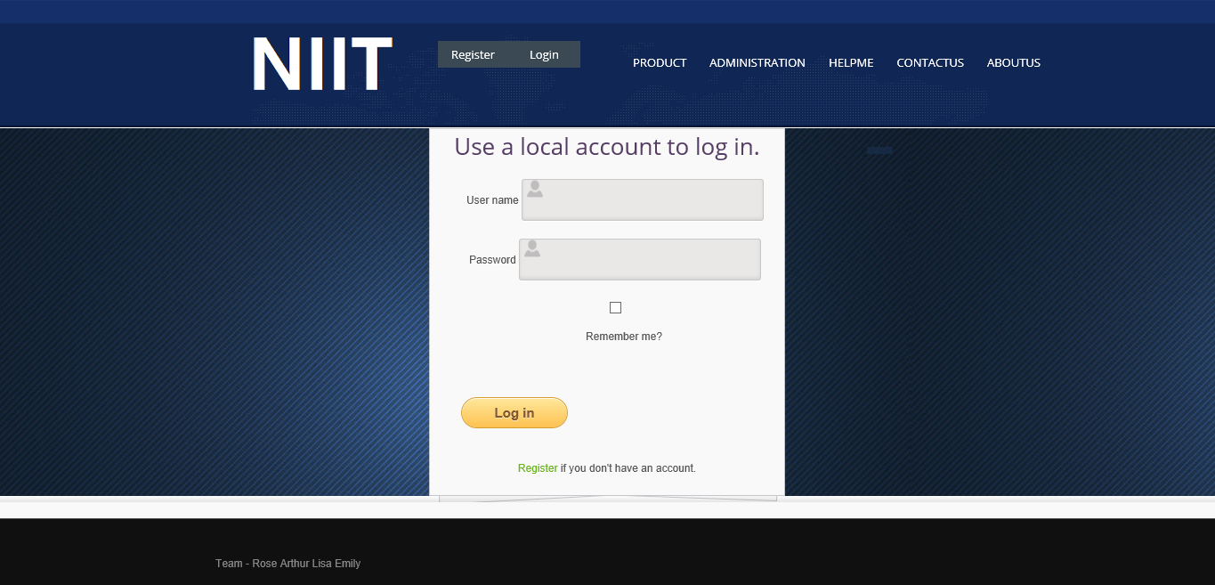

LOGIN

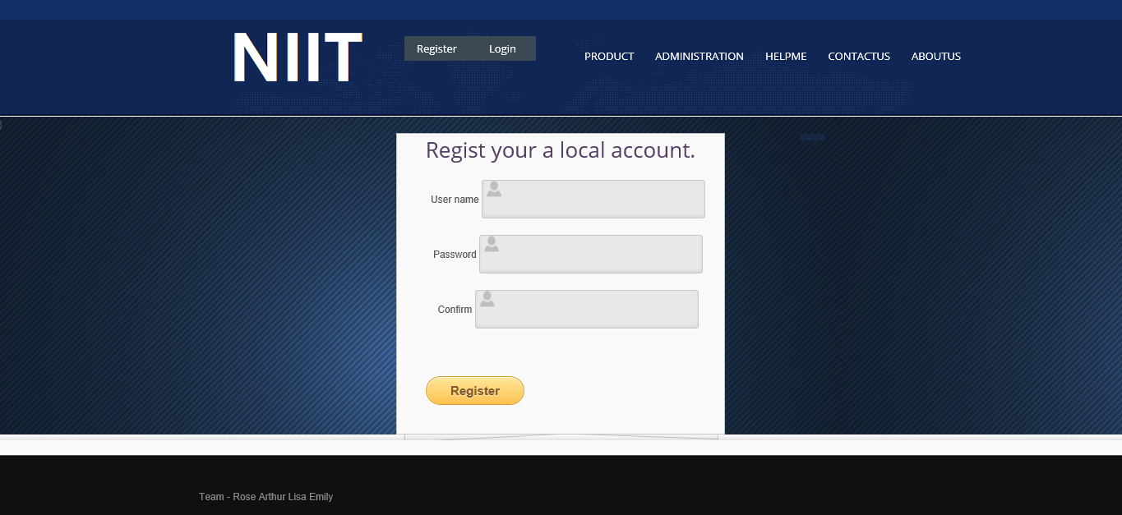

**FUNCTIONALITIES IN < Surface Book>**

**FUNCTIONALITIES IN < Pet Management System >**

PRODUCTS

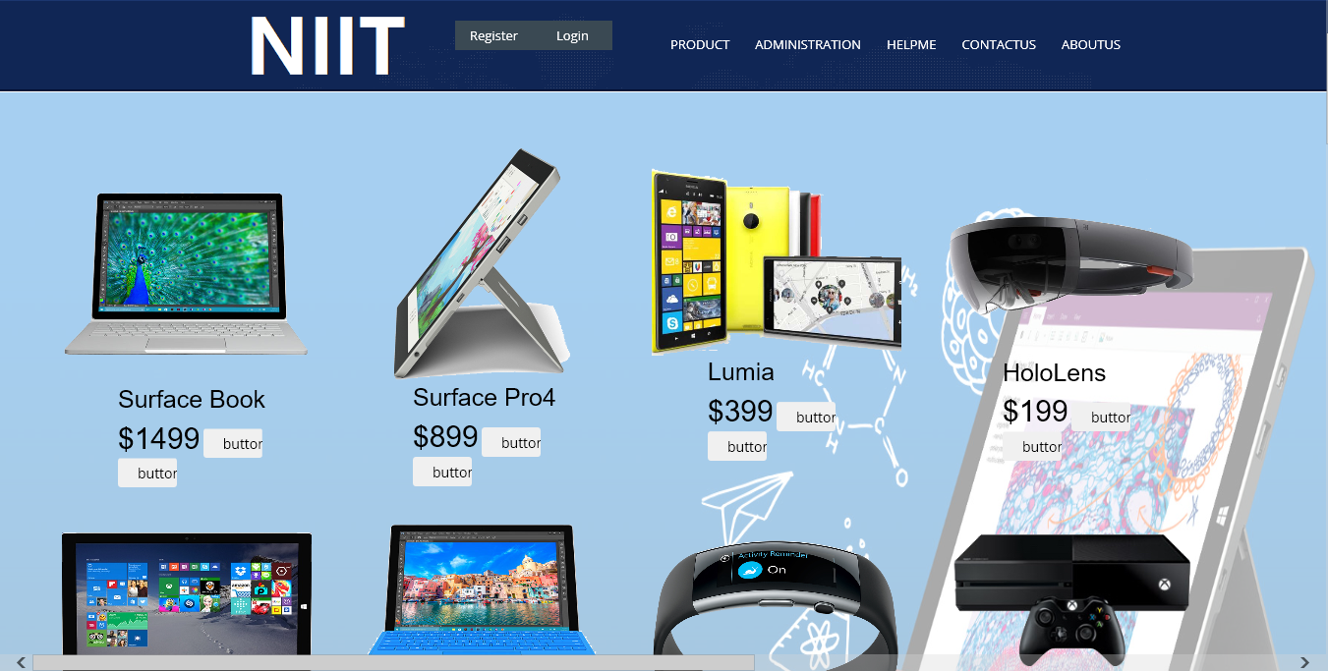

PRODUCTS

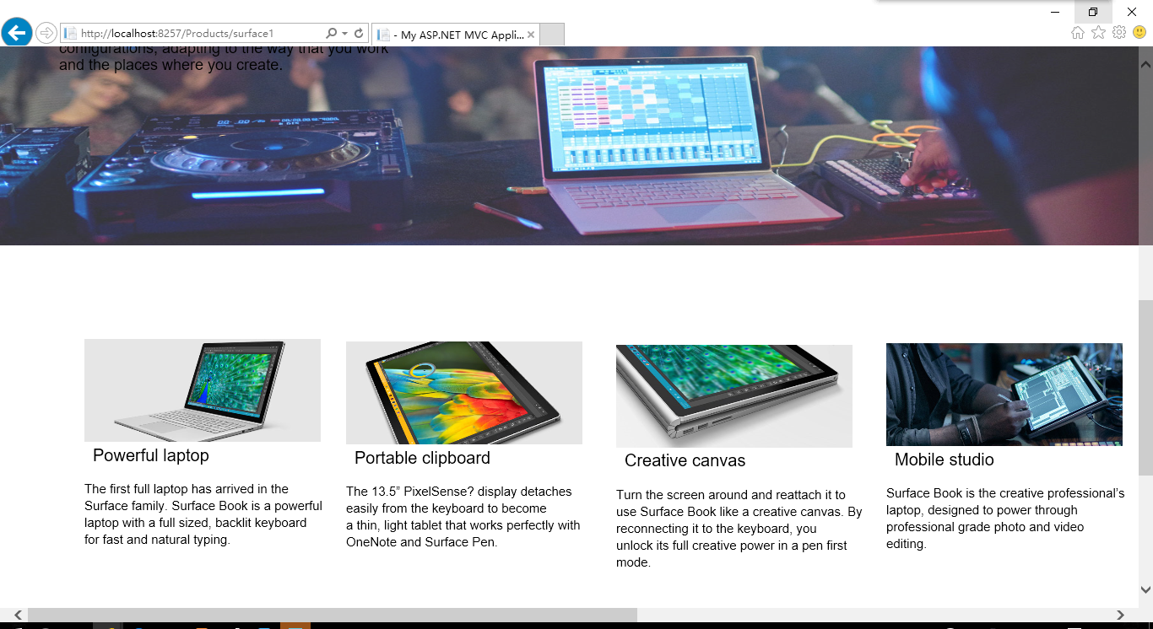

**FUNCTIONALITIES IN <Surface Book>**

MANAGE(create)

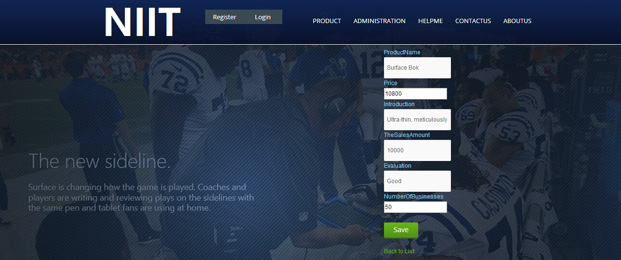

MANAGE(List)

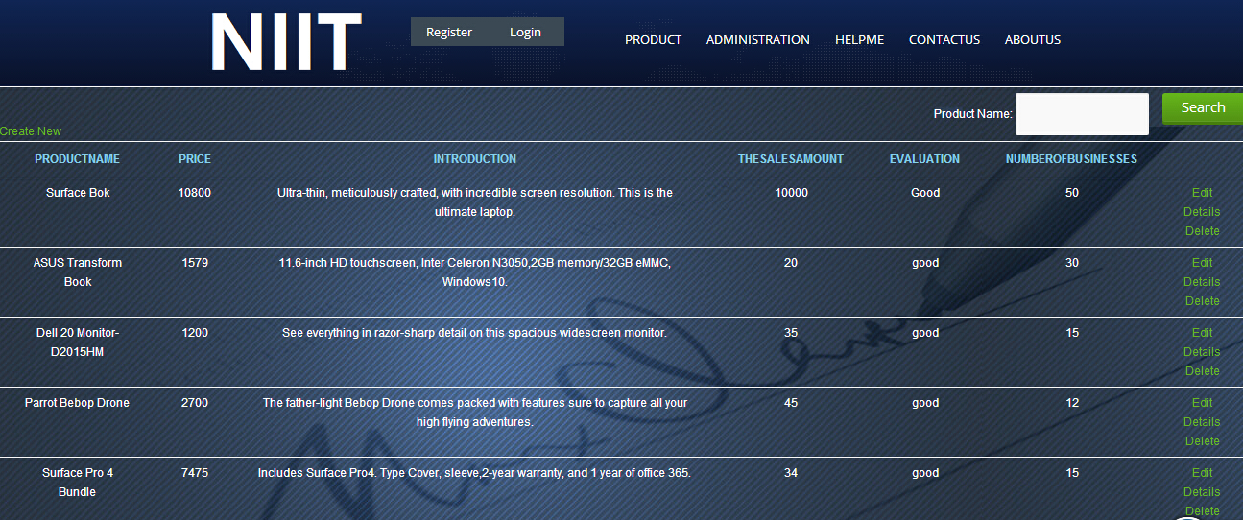

MANAGE(Edit)



**FUNCTIONALITIES IN < Surface Book >**

**FUNCTIONALITIES IN < Surface Book >**

MANAGE(Details)

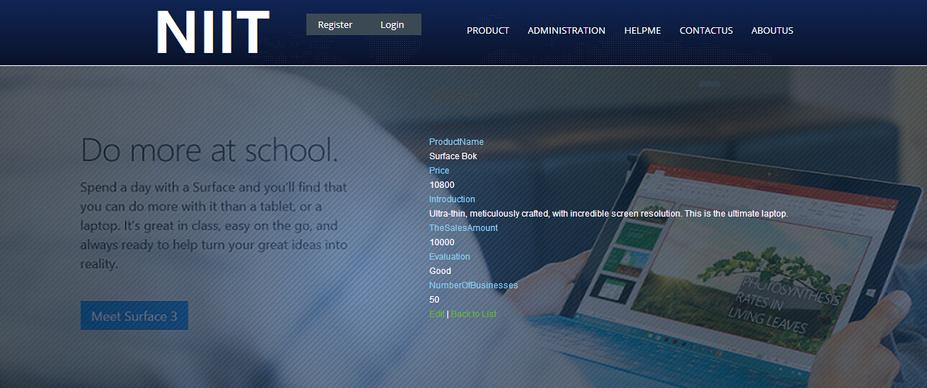

MANAGE(Delete)

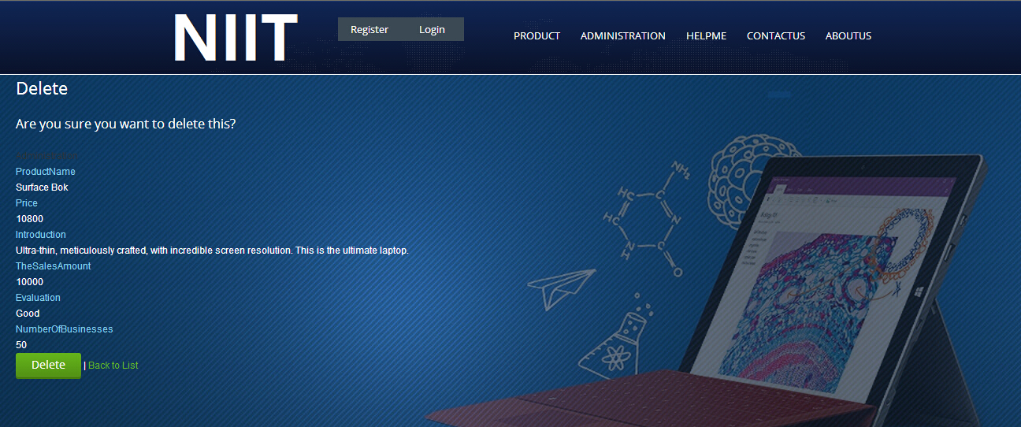

Home-Manage

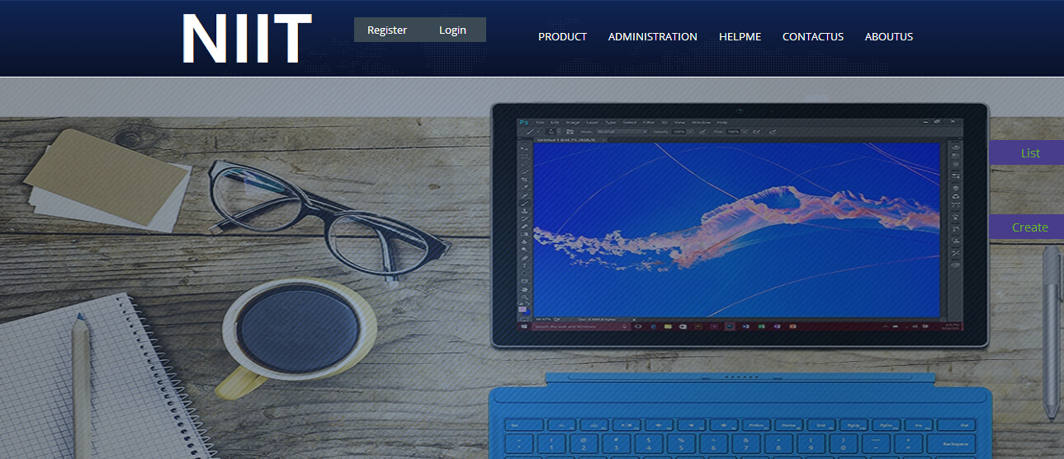

**Hardware :**computer，books

**Operating system :**Win XP,WIN7 ,WIN8,WIN10

**Software :**

Microsoft Office, Microsoft Visual Studio 2013

Microsoft Visual Studio 2015

**CONFIGURATION**

**CONFIGURATION**

**CONFIGURATION**